**Lab Report – Week 9**

CS2023 Data Structures and Algorithms

Dept. of Computer Science and Engineering, University of Moratuwa

|  |  |
| --- | --- |
| Name: Tharindu Perera | Index Number: 210472J |

|  |
| --- |
|  |

# Section1

### 2.

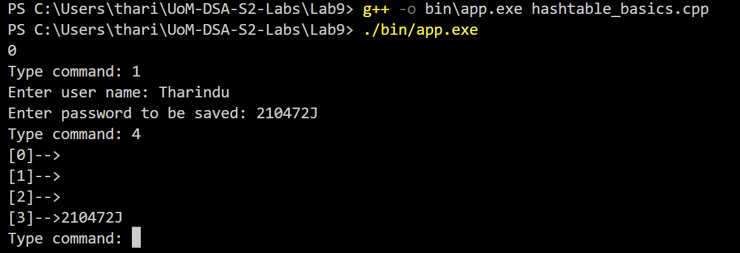

3.

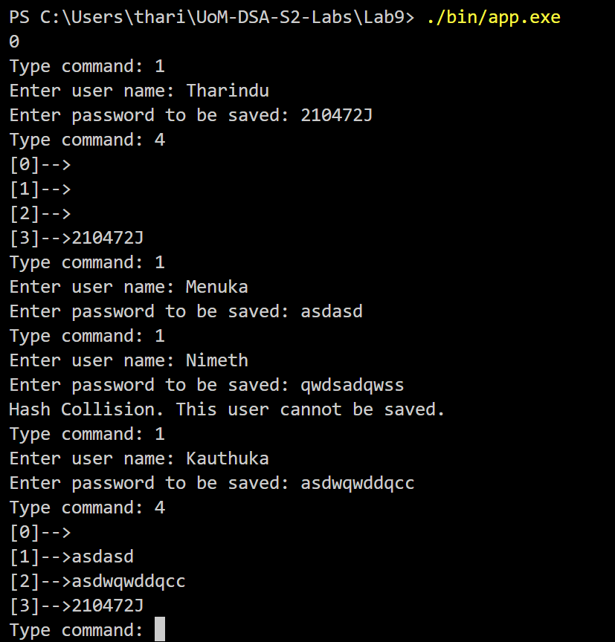

### 4.

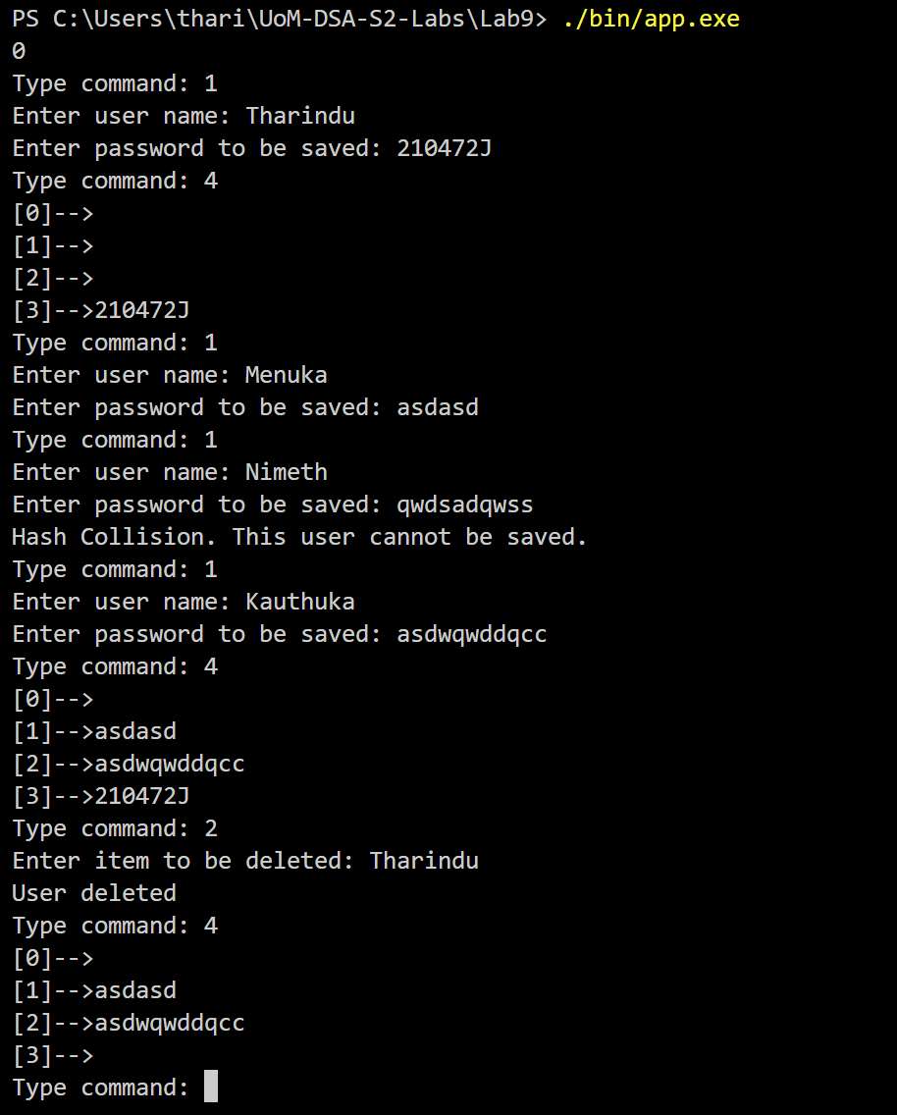

### 5.

Since there are only 4 buckets many hash collisions may occur. And they aren’t handled in a meaningful way in this simple implementation. There are several techniques to handle collisions:

Separate Chaining: In this technique, each slot in the hash table contains a linked list of items that have the same hash code. When a collision occurs, the new item is added to the end of the linked list at the corresponding slot.

Open Addressing: In this technique, when a collision occurs, a different slot in the hash table is chosen based on a predetermined algorithm. The most common open addressing algorithms are linear probing and quadratic probing.

Double Hashing: This technique involves using a second hash function to determine the next slot to try when a collision occurs. The second hash function is computed using the original key and is used to compute a step size to jump to the next slot.

# Section2

### 2.

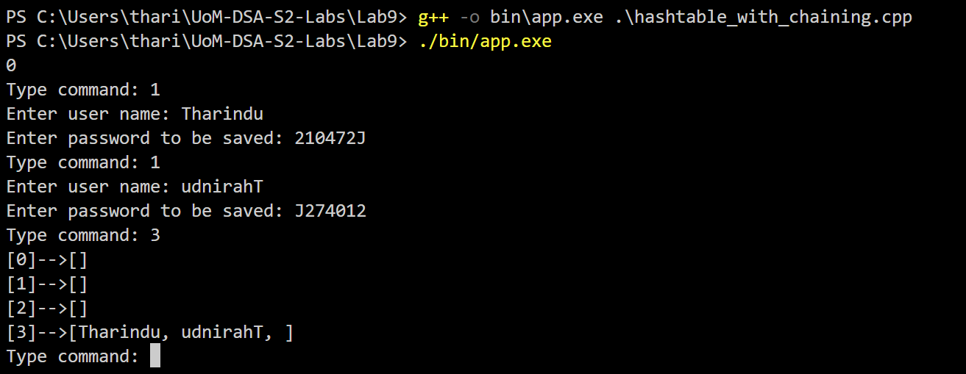

### 3.

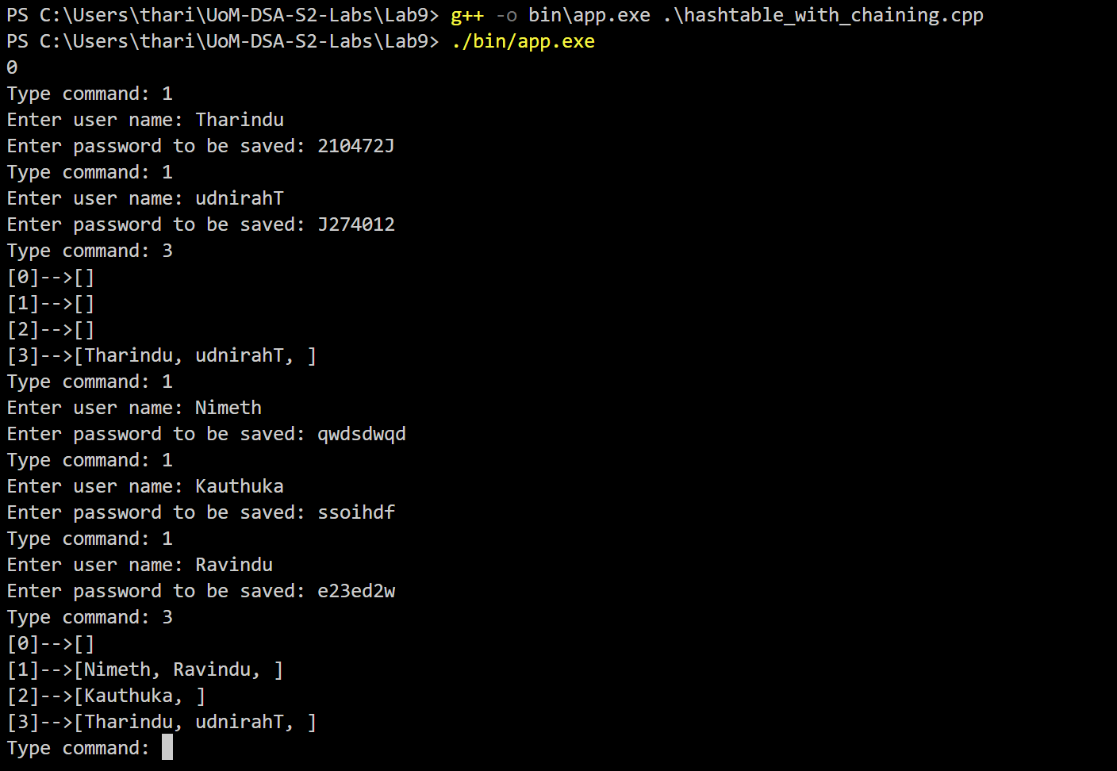

GitHub Link : [Tharindu6516/UoM-DSA-S2-Labs (github.com)](https://github.com/Tharindu6516/UoM-DSA-S2-Labs)